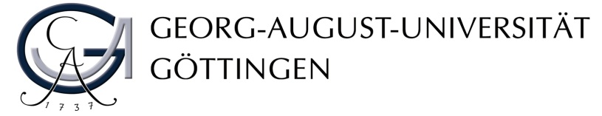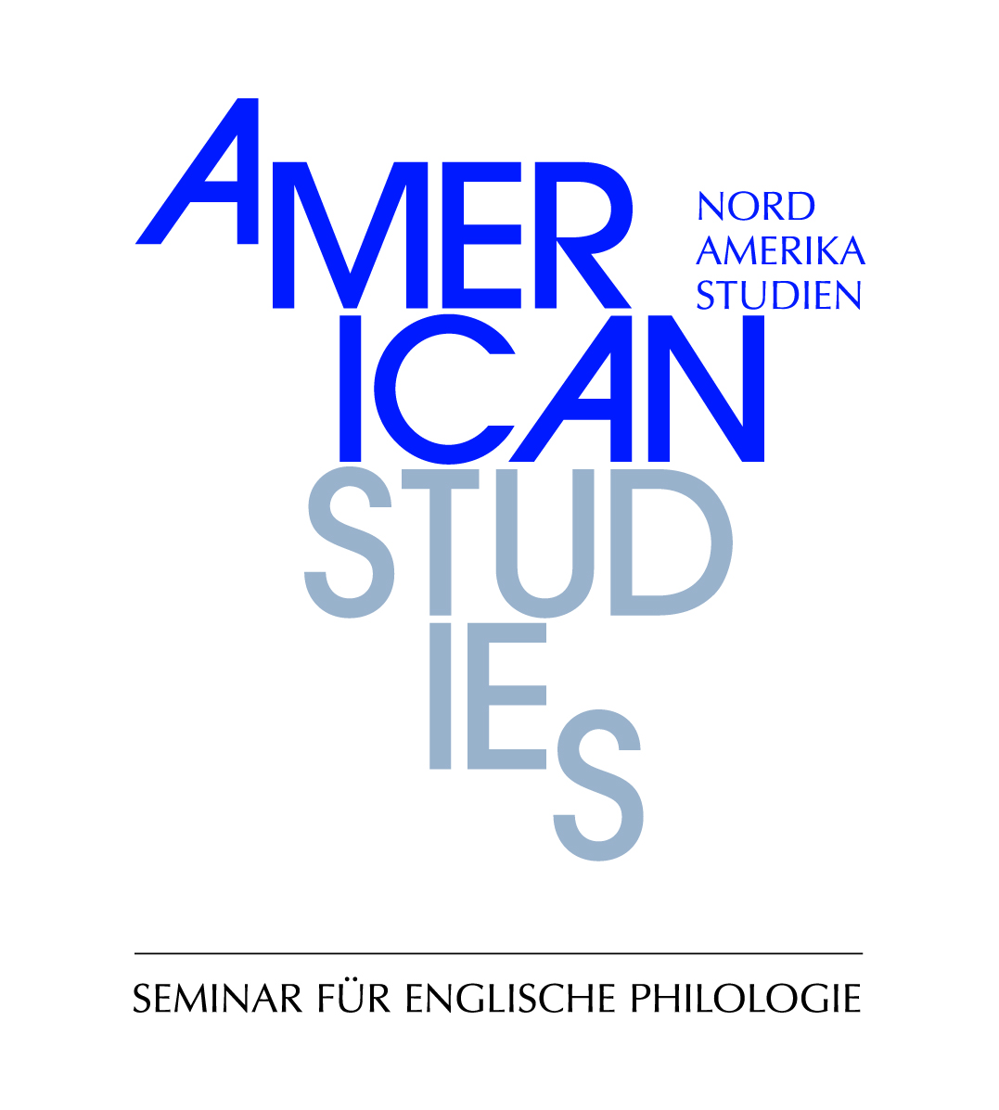

Die Abteilung

Nordamerikastudien | American Studies

des Seminars für Englische Philologie

lädt ein zu einem Gastvortrag:

**Prof. Dr. David Serlin**

**(University of California, San Diego)**

spricht über

**“Spectacles of Empire: Popular Entertainment and Visual Culture in Late-Nineteenth-Century America”**

Montag, 9. Juli 2012, 14:15 Uhr

ZHG 103

David Serlin is Associate Professor and Chair of Communication at the University of California at San Diego. He received his Ph.D. in American Studies from New York University in 1999. Serlin is the author of Replaceable You: Engineering the Body in Postwar America (University of Chicago Press, 2004), a study focused on medical technologies in the post-World War II era, for which he received the Alan Bray Memorial Book Award from the Modern Language Association. He has also edited and co-edited a number of books, among them *Policing Public Sex: Queer Politics and the Future of AIDS Activism* (1996) which won the Gustav Meyers Center Award for a Book on the Subject of Human Rights in North America, *Artificial Parts, Practical Lives: Modern Histories of Prosthetics* (2002), and *Imagining Illness: Public Health and Visual Culture* (2010). His newest book, *Window Shopping with Helen Keller: Architecture and Disability in Modern Culture* is forthcoming from the University of Chicago Press. In addition to his research in the field of disability studies and cultural studies of medicine and health, Serlin’s further interests include gender/sexuality studies and queer theory, architecture, urbanism, and the built environment.